**Target Journal:**

**Frass derived from black soldier fly (*Hermetia illucens*) larvae and yellow mealworms (*Tenebrio molitor*) affects growth performance and resistance to insect herbivores of field mustard (*Brassica rapa*)**

Shaphan Y. Chia, Joop J. A. van Loonand Marcel Dicke

Laboratory of Entomology, Wageningen University & Research, P.O. Box 16, 6700 AA Wageningen, the Netherlands.

**Abstract**

Frass, a mixture of insect excrement, leftover substrates and exoskeletons left after moulting has rapidly become popular. This byproduct contains nutrients and biomolecules that stimulate plant growth and induce plant resistance to insect herbivores. As insect production grows, so will the amount of frass. In the context of a circular economy and the concept of zero waste, it is necessary to valorise all components of production, including frass. Therefore, this study investigates the effect of frass as a soil amendment on plant growth and resistance to insect herbivory. In greenhouse experiments, soil was amended either with frass of black soldier fly (BSF) (*Hermetia illucens* L.) larvae, frass of mealworm (*Tenebrio molitor* L.) (2g kg−1), or unamended (control). Plant growth and performance of *Delia radicum* and *Plutella xylostella* larvae were measured on *Brassica rapa* plants. Raw BSF and mealworm frass reduced plant growth resulting in a smaller leaf area than the control. Raw mealworm frass showed higher growth than the raw BSF frass but did not differ from the unamended soil. Frass also enhanced plant resistance to herbivory by *D. radicum* and *P. xylostella* larvae. Raw BSF frass reduced larval survival and biomass of *D. radicum* pupae and survival of *P. xylostella* larvae. In contrast, raw mealworm frass increased larval survival and biomass accumulation of *D. radicum* and the survival of *P. xylostella* larvae. Interestingly, incubation of raw frass in the soil removed the plant growth inhibition and resulted in a significantly bigger plant leaf area, especially for mealworm frass. Therefore, frass could be used as a sustainable and natural alternative to conventional organic fertilisers and pesticides. Overall, our findings indicate that the effect of frass is a function of both frass type and quality. incubating frass in the soil before sowing seeds may make frass nutrients more available to plants and improve plant growth. Finally, our results suggest that a holistic approach that integrates frass as a fertiliser and other pest management strategies could be beneficial for sustainable agriculture.

**Keywords:** Insect frass, *Brassica rapa*, Soil amendment, Plant growth, Pest management, Insect herbivores

**Introduction**

In recent years, alternative protein sources for animal feed and human food have become an area of increasing interest as the world's population is expected to approach 10 billion by 2050 and the need for sustainable and eco-friendly practices. The use of insect-based feed, in particular, has gained significant attention due to its high nutritional value and low environmental impact. Among various insect species, black soldier fly (*Hermetia illucens* L.) larvae and yellow mealworms (*Tenebrio molitor* L.) have emerged as promising candidates for animal feed and human food respectively, due to their high protein content, rapid growth rate, and ease of cultivation (Chia et al., 2020; Mariod, 2020; Toviho & Bársony, 2022; Zulkifli et al., 2022).

Apart from their use as feed or food, insects have also been investigated for their potential as an organic fertiliser source. Insect frass, a mixture of insect excrement, leftover substrates, and exoskeletons left after moulting, is nutrient-rich and can enhance soil health and plant growth. For instance, the addition of frass to the soil may enrich the soil with specific beneficial soil microbes, such as bacilli, which may increase plant growth-promoting rhizobacteria (PGPR). Studies have indicated the potential of insect frass to increase crop yields (Barragán-Fonseca et al., 2022; Dzepe et al., 2022; Houben et al., 2021; Houben et al., 2020; Lopes et al., 2022; Poveda, 2021). Insect frass may also confer resistance to insect herbivores in plants (Barragán-Fonseca et al., 2022; Poveda, 2021). Induced systemic resistance has been linked to bacilli, making it a common kind of PGPR in agricultural soils. Plant growth-promoting rhizobacteria (PGPR) are a type of rhizosphere bacteria that colonise the roots and cause the host plant to be resistant to diseases and insect herbivory (Basu et al., 2021; Berendsen et al., 2012; Gadhave et al., 2016; Hu et al., 2018; Mahapatra et al., 2022; Pineda et al., 2010). Overall, plants and beneficial microorganisms can use frass as a nutrient and energy source when added to the soil. Inorganic N is released through microbial decomposition, which plants can utilise as organic N. Chitinolytic microbes have the ability to control insect pests biologically (Sharp, 2013). Thus, amending soil with chitin-rich residual streams may help beneficial antagonists. Chitin's influence on soil microorganisms through promoting the development and activation of chitinases in response to attacks by insect herbivores is one of the key responses to chitin-based treatments. Additionally, brassicaceous species exhibit bacilli-induced resistance to insects (Gadhave et al., 2016; Pangesti et al., 2013).

As the edible insect industry grows, so will the amount of frass (Chia et al., 2019; Houben et al., 2020; Poveda, 2021; Salomone et al., 2017). Following the rapid growth of the edible insect industry and frass's potential as a viable fertiliser and its contribution to the circular economy, the European Commission has enacted legislation (Regulation (EU) 2021/1925) to regulate its production and use. Analyses of frass produced by BSF larvae fed various food leftovers indicate that it ranges in total N content from 0.6 to 4.8 %, in total P content from 0.1 to 2.5 %, and in K content from 0.1 to 2.1%, as well as trace minerals and beneficial microorganisms (Basri et al., 2022; Choi & Hassanzadeh, 2019; Poveda, 2021). Mealworm frass, on the other hand, ranges in total nitrogen content from 2.7 to 7.8%, phosphorus from 1.0 to 1.5% and total potassium from 1.2 to 2.0%. It also contains calcium, magnesium, and micronutrients (Poveda et al., 2019). Moreover, BSFF and MWF contain chitin, which can enhance soil microbiota and generate antimicrobial peptides that serve as a plant's defence barrier (Choi & Hassanzadeh, 2019; Nurfikari & de Boer, 2021; Poveda et al., 2019; Schmitt & de Vries, 2020). High concentrations of phosphorus in BSFF promote nitrogen accumulation in plants (Klammsteiner et al., 2020). This makes it an excellent source of nutrients for plants, as it can improve soil fertility, increase crop yields, and enhance plant growth. By preventing, valorizing, and reintroducing relevant nutrients and organic matter into the soil, the use of frass can help to close the nutrient cycle in insect farming. This strategy contributes to the development of a zero-waste food production system and highlights the significance of identifying sustainable sources of organic matter for soil amendment and plant growth.

Field mustard (*Brassica rapa* L.) is a member of the Brassicaceae family and is widely cultivated for food, oil, and feed, and it has a high economic value due to its nutritional, medicinal, bio-industrial, and crop rotation capabilities (Young-Mathews, 2012). However, it is also a preferred host for various insect herbivores, including the root-feeding cabbage root fly *Delia radicum* and the shoot-feeding diamondback moth *Plutella xylostella* (Ahuja et al., 2010), which can cause substantial productivity and economic losses, posing a danger to global food security (Ahuja et al., 2010). Plant fitness and, by extension, crop yield, are influenced in large part by plant-insect interactions. To mitigate plant damage caused by insect herbivores, various methods have been employed, including the use of chemical pesticides. However, the overuse of pesticides has led to numerous environmental and health concerns (Nicolopoulou-Stamati et al., 2016), Therefore, effective, sustainable, and safe alternatives for managing insect herbivores are required.

Previous research has demonstrated that insect frass can improve plant growth and development, and increase nutrient uptake (Abiya et al., 2022; Dzepe et al., 2022; Houben et al., 2021; Houben et al., 2020; Lopes et al., 2022; Poveda, 2021; Poveda et al., 2019). In the wild, frass deposition by insect herbivores has shown increased soil carbon, nitrogen, and nitrates. Frass can also affect soil nitrogen dynamics in the forest (Frost & Hunter, 2004). The mechanisms causing these effects are thought to be linked to the presence of beneficial microorganisms in the frass, as well as the release of plant growth-promoting molecules (Barragán-Fonseca et al., 2022; Poveda, 2021). At the same time, plant growth inhibition due to frass application has been reported (Alattar et al., 2016; Gärttling et al., 2020).

Plant damage by insects threatens food security. Insect herbivore populations are strongly influenced by crop tissue nitrogen content and metabolism, which are affected by growth stage, environmental conditions, and agrochemical inputs (Chen et al., 2010). Pesticide and nitrogen-based fertiliser applications can increase insect herbivore damage by increasing plant nutrition and attractiveness to herbivores and altering plant morphological and chemical defenses (Chen et al., 2010; Martinez et al., 2021; Sun et al., 2020). Insecticides and fungicides can disrupt plant metabolism and predispose plants to stress or toxicity, which may contribute to field pest pressure. Therefore, circular agricultural practises that help to reduce the environmental impact of chemical inputs while also promoting sustainable food systems are needed. Till date, there is limited research on the potential of insect frass to enhance plant development and insect resistance. So far, a recent study showed that mealworm exuviae did not affect shoot and root dry biomass of *B. oleracea* (Wantulla et al., 2022). The study further recorded a reduced survival of *D. radicum* larvae in BSFF-exposed soil, but mealworm exuviae did not affect larval survival and biomass compared to a synthetic fertiliser. However, the study (Wantulla et al., 2022) did not investigate the effects of MWF, which is the most abundant byproduct of edible insect cultivation. Furthermore, evaluations of plant growth and herbivore performance have largely been limited to a few plant species and insect herbivores under soil treatment with frass, thus limiting the generalization of the results. To address this knowledge gap, it is crucial to examine the impact of various types of insect frass and to consider other plant species and their resistance to biotic stressors, such as insect herbivory. It is also important to extend investigations to multiple herbivores to understand potential variations in their interactions with frass-exposed plants. While the effect of frass on crop growth has received increased attention, its potential to enhance plant resistance to biotic stressors remains largely unexplored. Intriguingly, the question of whether insect frass can fully replace traditional organic and mineral fertilisers as well as chemical insecticides in agricultural systems still requires further research into. There is currently no single research that can definitively answer this question and several studies addressing the challenge of soil fertility have mainly focused on frass application to improve soil health and promote crop growth, with limited attention to its potential effect on insect herbivore performance (Poveda, 2021; Wantulla et al., 2022). Exploring the effects of insect frass on plant resistance to herbivores, can provide insights into its use as a natural pest management strategy and reduce the need for chemical pesticides.

In this study, we aimed to investigate the effects of frass derived from BSF larvae and yellow mealworms on the growth performance and resistance to herbivores (*D. radicum* and *P. xylostella*) of *B. rapa*. Specifically, we hypothesised that frass would enhance the growth performance of *B. rapa* and confer resistance to the herbivores, compared to control plants that received no frass., due to its high nutrient content, which can improve soil quality and provide essential nutrients for plant growth, and by releasing biomolecules and cues that alter plant defenses against insect herbivores. Additionally, we hypothesised that incubating frass in the soil or composting it will enhance its effectiveness as a soil amendment and lead to greater plant growth than non-incubated or uncomposted frass. Composting is a common method of preparing organic materials for use as soil amendments. The findings of this study will contribute to our understanding of the potential benefits of using insect frass as a sustainable and environmentally friendly fertilizer in agriculture.

**Materials and Methods**

**Experimental facility and greenhouse soil**

We conducted greenhouse experiments to assess how frass resulting from the production of two edible insect species affected the growth of field mustard (*Brassica rapa* L.) plantsand the survival of a belowground and an aboveground insect herbivore when used as a soil amendment. The study was conducted in the greenhouse facilities at Unifarm, Wageningen University & Research, the Netherlands. The soil used in this study was collected at Unifarm’s organic experimental farm Droevendaal. The farm had been used to grow various brassicaceous plant species since 2011 and black mustard (*Brassica nigra* L.) had recently been grown at the location selected for soil collection.**Raw material and soil amendments**

The frass used in this study was obtained from two commercially reared edible insect species by two different companies: (1) black soldier fly larvae *Hermetia illucens* L. (Diptera: Stratiomyidae) provided by Bestico, Berkel en Rodenrijs, the Netherlands and (2) yellow mealworm larvae, *Tenebrio molitor* L. (Coleoptera: Tenebrionidae), provided by Nijenkamp-Voederdieren, Oldenzaal, the Netherlands. The frass was heated at 60 °C for 24 h, pulverised and then stored in air-tight containers at room temperature for 78 days. We refer to the pulverised frass as *“raw frass”* to differentiate it from other forms of frass used in this study including *“incubated frass”* and *“composted frass”* (see details in sections below). The soil was amended with the pulverised frass by adding 2 g of frass per kg of soil that had previously been sieved (5 mm) to remove large debris. To mix frass and soil, 20 g of frass was added to 10 kg of soil in plastic bags and mixed thoroughly by hand until there were no visible clumps of the frass. Soil amended with frass of the black soldier fly larvae was labelled as “BSFF” while soil amended with frass of yellow mealworms was labelled as “MWF”. The same procedure was followed for the control (NoFrass), except that no frass was added. In two trials (Trial 1 and Trial 2), raw frass was added to the soil. Subsequently, samples of the raw frass were either incubated in the soil (Trial 3) or composted (Trial 4) before being added to the soil for plant growth. Trial 2 is a repeat of Trial 1 under similar conditions and procedures. Trial 1 started (i.e., seed germination) on January 30, 2021; Trial 2 started on March 1, 2021; Trials 3 and 4 started on March 26, 2021.

**Insect rearing**

*Delia radicum*

The cabbage root fly, *Delia radicum* L. (Diptera: Anthomyiidae) is an important pest of brassicaceous vegetables. Larvae (< 24 h since hatching) of *D. radicum* were obtained from the insect-rearing unit of the Laboratory of Entomology, Wageningen University & Research. They had been fed on rutabaga (*Brassica napus*) until pupation. Adults were kept in gauze cages and fed on a mixture of sugar, milk powder, yeast and honey. Water was provided in cotton wool. The insect colony was maintained in a climate cabinet (22 ± 1 °C, 50-70 % RH).

*Plutella xylostella*

The diamondback moth (DBM), *Plutella xylostella* L. (Lepidoptera: Plutellidae) is one of the most destructive insect herbivores of cruciferous plants worldwide (Wei et al., 2013). Neonate larvae of DBM were obtained from the insect rearing unit of the Laboratory of Entomology, Wageningen University & Research, where they were fed on Brussels sprouts plants (*Brassica oleracea* variety *gemmifera* cultivar Cyrus) in greenhouse conditions (22 ± 3 °C, 50-70 % RH).

**Field mustard (*Brassica rapa*) seeds and germination**

Field mustard (*Brassica rapa* L., Brassicaceae) is an annual or biennial herb (Ilyas et al., 2022). *Brassica rapa* seeds originated from a natural population and were kindly provided by Dr. Erik Poelman (Laboratory of Entomology, Wageningen University). Before sowing, the seeds were stratified by maintaining them in moist filter paper at 4 °C for 7 days to break seed dormancy. Seeds were germinated using unamended soil in the greenhouse (22 ± 3 °C, 60 ± 2 % RH). In this study, seeds germinated in unamended soil (NoFrass) had a high germination rate (> 90%), whereas those sown directly into the frass-amended soil had a slightly lower germination rate, but there were no significant differences among the trials (*χ2* = 2.97; df = 3; *p* = 0.3961; Table S1).

**Plant growth performance in soil amended with raw frass**

At the emergence of the first true leaf (7 days old), seedlings were transplanted individually into amended and unamended soil in 1 L plastic pots placed individually in round saucers (16 cm wide, 1.8 cm deep). Plants were randomly assigned to the two soil amendments (BSFF and MWF) in 30 replicate pots placed on a table in a greenhouse compartment. Plants were watered twice per week (and three times per week from week 3 since germination) by filling the saucer until the top soil became moist. Weeds in experimental pots were manually removed. This experiment was repeated after four weeks following the same procedure. At 21 days after seed germination, plant growth measurements included a leaf count to record the number of leaves per plant, and the width (cm) of the second most mature true leaf (leaf formed after seedling transplant) measured at the broadest point of the leaf. The same measurements were repeated at 28, 35 and 42 days since germination. Every week, the next mature true leaf was measured until the onset of plant bolting (development of flowering stems). From this point, plants were monitored daily and the number of days until the first flower to emerge was recorded as the time until flowering.

**Assessment of plant resistance to insect herbivory**

The resistance of raw-frass-exposed *B. rapa* plants to two insect herbivores, *D. radicum* and *P. xylostella,* was assessed by recording larval survival, pupal biomass and leaf damage. When plants were four weeks old, ten larvae (< 24 h old) of *D. radicum* were released at about 0.5 cm into the soil close to the stem of each potted plant. Their survival was assessed when the larvae fed on roots of frass-exposed *B. rapa* plants. Ten plants per treatment and control (BSFF, MWF and NoFrass) were inoculated. After 21 days according to the life cycle of *D. radicum*, all plants were uprooted and all pupae and larvae retrieved per plant were recorded. Wet pupal weight was recorded using an Ohaus Adventurer Pro AV213 balance with an accuracy of 0.001 g. To assess the effect of soil amendment on pupal development, all pupae retrieved from roots of plants exposed to the soil treatments were placed in a Petri dish at 22 ± 1 °C, 50-70 % RH. The number of adult flies that emerged and the time (days) taken to emerge were recorded daily until all pupae had either emerged as flies or appeared to be dead. This experiment was repeated four weeks later, following the same procedure.

To assess the effect of raw-frass-exposed plants on the survival of *P. xylostella* larvae, ten second-instar larvae were inoculated on one fully expanded leaf of each replicate *B. rapa* plant. Inoculated plants were immediately enclosed in transparent mesh bags to contain the larvae and prevent their escape. The mesh bags were monitored daily to record the pupation of the larvae. The experiment was terminated when all larvae had either pupated or appeared to be dead. Ten replicate plants per treatment (BSFF, MWF or NoFrass) were used in this experiment. This experiment was repeated once more following the same procedure.

The amount of leaf damage by the larvae of *P. xylostella* on raw-frass-exposed *B. rapa* plants was assessed visually on a 1-to-7 scoring scale (Fig. 1). According to this scale, a score of 1 means no visible damage to the plant, and a score of 7 means extensive damage to the plants (Robin et al., 2017). The average values from ten plants were calculated for each soil amendment (Niemann et al., 2020).

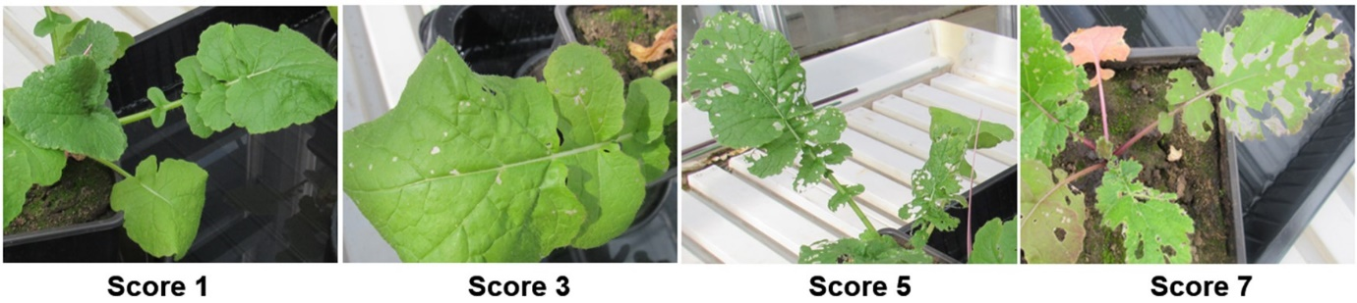

**Figure 1.** Visual representation of feeding scores used to assess the extent of leaf damage in greenhouse-grown *Brassica rapa* plants by larvae of Diamondback moth (DBM) *Plutella xylostella*. The score ranged from ‘1’ to ‘7’ with ‘1’ being scored for leaves with no damage symptoms and ‘7’ being scored for maximum damaged leaves. Intermediate values on the scale represent different levels of damage (Robin et al., 2017).

**Incubation and composting of raw frass: effects on plant growth performance**

*Incubation of ‘raw frass’ in the soil*

Incubation was achieved by mixing 2 g of raw frass per kg of soil. The amended soil was placed in 0.5 L plastic pots in saucers (14 cm wide, 1.5 cm deep). The soil mixture in pots was moistened by filling the saucers with water twice a week. This incubation of frass was maintained for 16 days under greenhouse conditions. The same procedure was followed for the unamended soil (control) except that no frass was added. Stratified seeds of *B. rapa* were sown directly into the soil. Three seeds were sown in each pot and seven days after germination, seedling numbers were reduced to maintain only one seedling per pot. When plants were 14 days old, measurements of the leaf width (cm) and the number of leaves per plant were taken as described for *raw frass*. Six replicate plants per treatment were used in this study and measurements were repeated on the same plants at 21, 28 and 35 days since germination. Plants were further monitored and the first flowering date was recorded and used to calculate the flowering time since germination.

*Composting of ‘raw frass’*

Fifty grams each of black soldier fly larval frass and yellow mealworm frass were placed in plastic boxes (17.5 x 12.5 x 6.5 cm). The pulverised raw frass samples were moisturized with 100 mL of water and the frass in containers was covered with a perforated aluminium foil to allow ventilation, but also reduce evaporation and maintain a high temperature inside the box relative to the external environment. Frass inside the box was aerated by stirring it vigorously after every five days using a spatula. The composting lasted for 38 days. Composting of frass was terminated by removing the aluminium foil cover and allowing the compost to air dry for 18 days. Then, the composted frass was pulverised and added to the soil at 2 g per kg of soil. As described above, three stratified seeds were sown in each pot and seven days after germination, seedling numbers were reduced to maintain only one seedling per pot. Percent seed germination in amended and unamended soil was recorded. Twelve replicate plants per soil treatment were used in this study and the number of leaves and leaf width per plant were measured at 14, 21, 28 and 35 days since germination. Plants were further monitored and the first flowering date was recorded and used to calculate the flowering time since germination.

**Data processing and statistical analysis**

All analyses were performed using the R environment for statistical computing (version 4.2.2) (R Core Team, 2022). A linear regression model estimated leaf area *(area = 0.88735*(leaf width)2+0.93503*leaf width)* from linear measurements (leaf width) (Tartaglia et al., 2016). The normality of data was verified by visualisation using boxplots and QQ plots as well as subjected to the Shapiro-Wilk test. Homogeneity of the variances was checked using Levene’s test. Data on leaf area and the number of leaves were analysed with a generalised linear mixed effect model (GLMM) using the *‘glmer* function in the ‘*lme4’* package (Bates et al., 2014). For each trial, soil amendment (treatment) was included in the model as a fixed-effect factor while time point and plant ID were included as random-effect factors. Pupation (expressed as % survival of larvae) data were analysed with a Poisson-based model. Pupal biomass and leaf damage score data were analysed with a generalised linear model (GLM) using the *‘glm* function in the *‘glm2’* package. To determine the effect of soil amendments on the development of pupae of *D. radicum,* dataon the proportion of adult flies that emerged were analysed with a Chi-square test of equality of proportions (Adedia et al., 2020). For the fly emergence time of *D. radicum*, and flowering time of *B. rapa* plants, data were analysed with the Poisson regression model using the *‘glm’* function, estimated by the maximum likelihood to capture the relationship between the number of days taken for flies to emerge from pupae, and for the first flower to emerge (Zeileis et al., 2008). The ‘*Anova’* function of the ‘*car’* package was used to generate the model output for the main effects with Chi-square (*χ2*) values, degrees of freedom (df) and *p*-values using the Wald Chi-square test (Fox et al., 2012). The Akaike’s Information Criterion (AIC) was used to estimate the degree of fit of statistical models with the lowest AIC values considered as best in estimating the model prediction error. The mean effects of treatment were considered significant at *p* < 0.05. The *‘emmeans’* function was used to perform pairwise comparisons among soil treatments with *p*-values adjusted according to the Tukey method for comparing estimates when a significant effect of soil treatment was detected in the leaf area, number of leaves, larval survival and pupal weight (Lenth & Lenth, 2018). Mean separation in the flowering time of *B. rapa* plants was achieved using Fisher's Least Significant Difference post-hoc test. Following a significant Chi-square test of equality of proportions, the Marascuilo procedure for multiple comparisons was used to determine significance of differences (Wagh & Razvi, 2016).

**Results**

**Effects of raw frass on the growth and development of *B. rapa* plants**

Amending soil with either raw BSFF or raw MWF affected the growth of *B. rapa* plants (*χ2* = 186.87; df = 2; *p* < 0.0001; Figure 2). Compared to the control (NoFrass), amending soil with BSFF and MWF resulted in a significantly smaller leaf area, with BSFF showing the lowest value (Figure 2). When this experiment was repeated under similar conditions, comparable results were recorded (*χ2* = 121.68; df = 2; *p* < 0.0001; Figure S1).

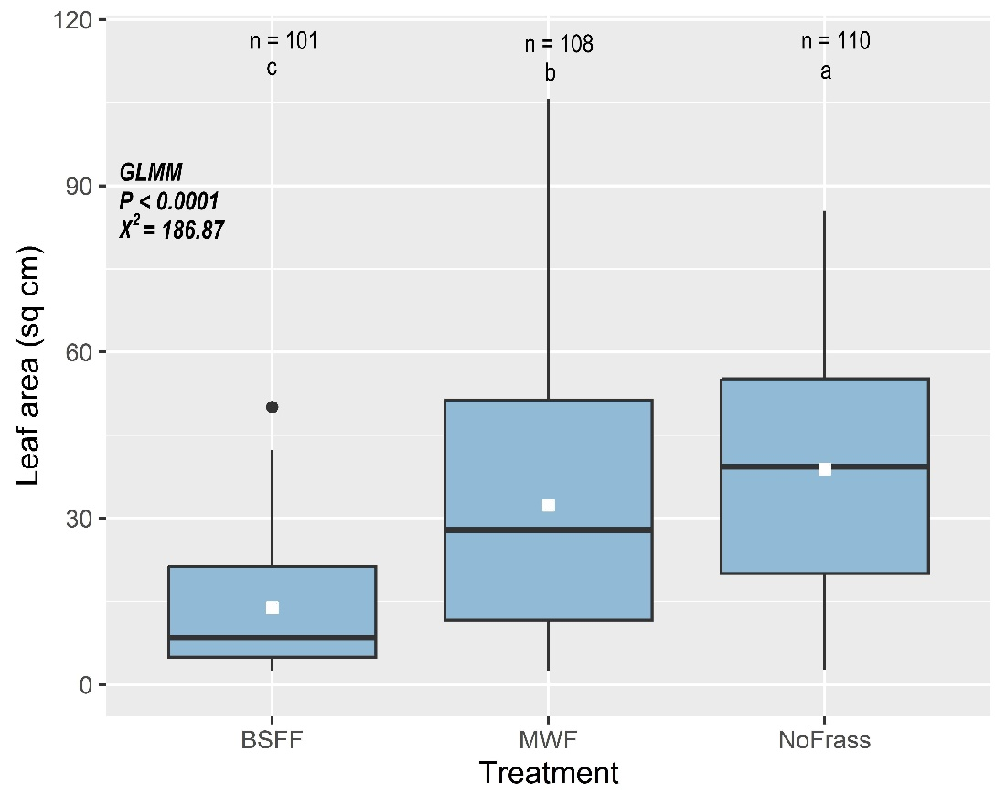

**Figure 2**. Leaf area of *Brassica rapa* plants grown in unamended soil (NoFrass; control) or amended with raw BSF frass (BSFF) or raw yellow mealworm frass (MWF). Boxplots show the median (horizontal bold line), and minimum and maximum values. The dot represents an outlier. The white square on each box represents the mean leaf area per plant. Data were analysed with a generalised linear mixed effect model (GLMM). n is the number of measurements per treatment. Boxes with different letters are significantly different (Tukey's post hoc test, *p* < 0.05).

The addition of raw BSFF or raw MWF to the soil resulted in a significantly smaller number of leaves per *B. rapa* plant when compared to the unamended control (*χ2* = 113.94; df = 2; *p* < 0.0001; Figure S2A). Similar results were recorded when this experiment was repeated under comparable conditions (*χ2* = 162.53; df = 2; *p* < 0.0001; Figure S2B).

Amending soil with raw BSFF or raw MWF resulted in significant differences in the time until flowering of *B. rapa* plants (*χ2* = 6.25; df = 2; *p* = 0.0441; Figure S3). The application of BSFF resulted in a longer time until flowering than MWF and NoFrass (Figure S3A). There was no significant effect of soil treatment on flowering time when this experiment was repeated under similar conditions (*χ2* = 1.44; df = 2; *p* = 0.4859; Figure S3B).

**Effect of raw frass on the survival of *Delia radicum* larvae**

Frass treatments affected the number of *D. radicum* larvae that survived after a 21-day root infestation of *B. rapa* (*χ2* = 31.02; df = 2; *p* < 0.0001; Figure 3). Amending soil with BSFF resulted in the lowest mean survival (49%) of *D. radicum* larvae, whereas MWF resulted in the highest mean larval survival (68%) compared to NoFrass with 59% mean larval survival (Figure 3). Similar results were recorded when the experiment was repeated under comparable conditions (*χ2* = 56.28; df = 2; *p* < 0.0001; Figure S4).

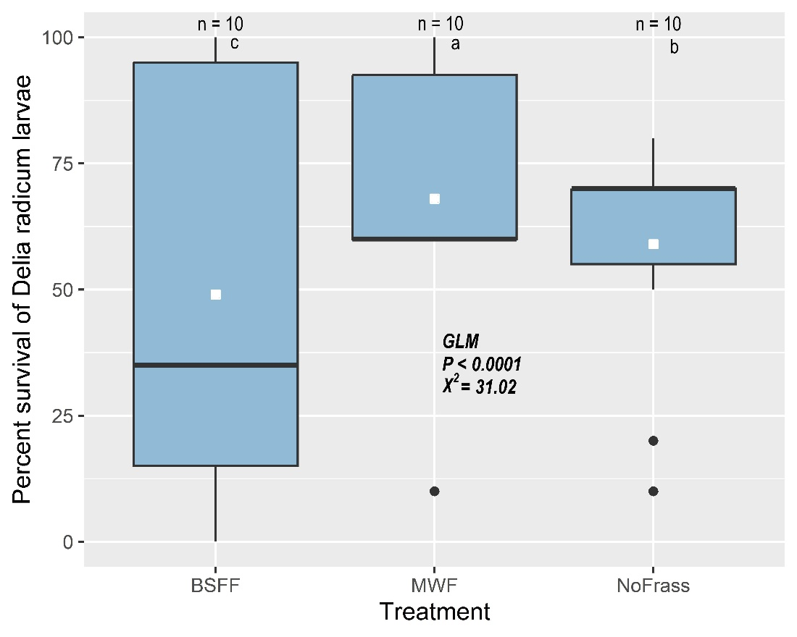

**Figure 3.** Survival of *Delia radicum* larvae on roots of *Brassica rapa* plants grown in unamended soil (NoFrass; control) or soil amended with raw BSF frass (BSFF) or raw yellow mealworm frass (MWF). Boxplots show the median (horizontal bold line), and minimum and maximum values. The dots represent outliers. The white square on each box represents the mean larval survival per plant. Data were analysed with a generalised linear model (GLM). n is the number of replicates per treatment. Boxes with different letters are significantly different (Tukey's post hoc test, *p* < 0.05).

**Effect of raw frass on the weight of *Delia radicum* pupae**

Biomass of *D. radicum* pupae retrieved from the roots of *B. rapa* plants was influenced by soil treatment (*χ2* = 81.28; df = 2; *p* < 0.0001; Figure 4). Treatment with raw BSFF resulted in the lowest pupal biomass whereas MWF resulted in the highest biomass (Figure 4). However, when the experiment was repeated under comparable conditions differences were only marginally significant (*χ2* = 5.12; df = 2; *p* < 0.0773; Figure S5).

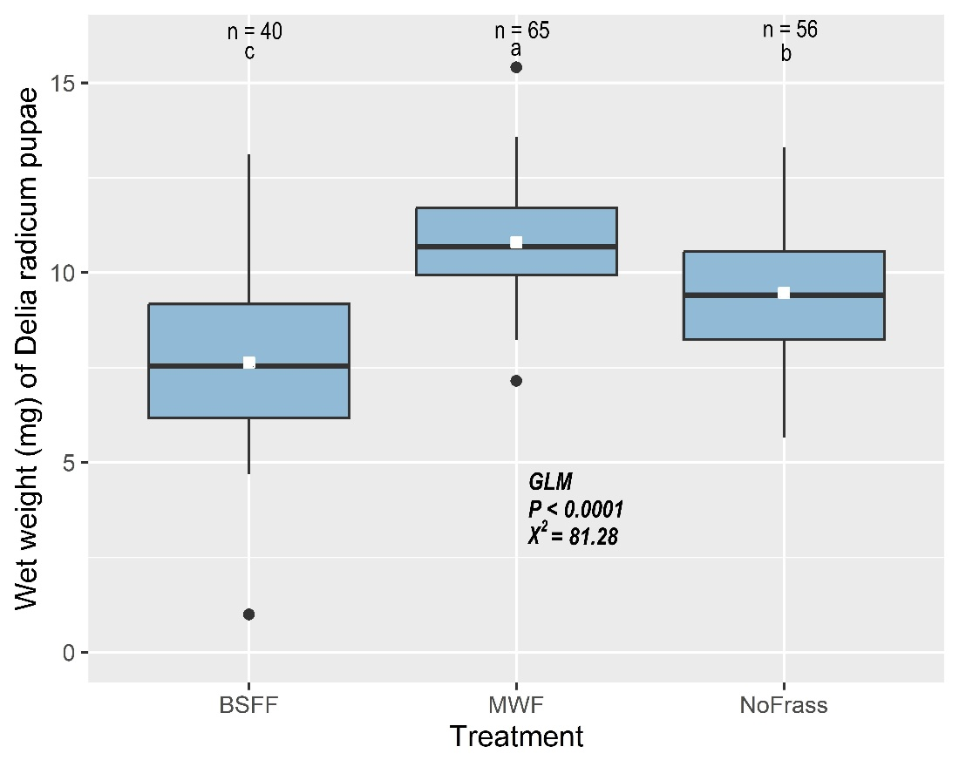

**Figure 4.** Biomass (mg) of *Delia radicum* pupae retrieved after a 21-day root infestation of *B. rapa* grown in unamended soil (NoFrass; control) or soil amended with raw BSF frass (BSFF) or raw yellow mealworm frass (MWF). Boxplots show the median (horizontal bold line), and minimum and maximum values. The dots represent outliers. The white square on each box represents the mean pupal weight. Data were analysed with a generalised linear model (GLM). n is the number of pupae weighed per soil treatment. Boxes with different letters are significantly different (Tukey's post hoc test, *p* < 0.05).

**Effect of raw frass on the emergence of *Delia radicum* adult flies**

The proportion of adult *D. radicum* flies that emerged from pupae was significantly affected by soil treatment (*χ2* = 6.06, df *=* 2*, p* = 0.0484; Figure S6A). The application of BSFF resulted in a significantly (Figure S6A) lower proportion of flies that emerged than MWF, but the effect was not significantly different from the NoFrass treatment (Figure S6A). The proportion of flies that emerged from plants exposed to MWF was similar to that from plants in the NoFrass group (Figure S6A). Although a similar pattern of emergence was recorded when this experiment was repeated under similar conditions, the proportion of flies that emerged did not differ significantly among soil treatments (*χ2* = 0.24, df *=* 2*, p* = 0.8896; Figure S6B).

The time it took pupae to emerge as adult flies did not differ significantly among soil treatments (*χ2* = 0.92, df *=* 2*, p* = 0.6314; Figure S6C), and similar results were recorded when the experiment was repeated under similar conditions (*χ2* = 0.11, df *=* 2*, p* = 0.9468; Figure S6D).

**Effect of raw frass on the survival of *Plutella xylostella* larvae on *Brassica rapa* plants**

The number of *P. xylostella* larvae that survived on *B. rapa* plants differed significantly among treatments (*χ2* = 129.23; df = 2; *p* < 0.0001; Figure 5). Amending soil with BSFF resulted in the lowest mean larval survival whereas MWF resulted in the highest mean larval survival (pupae retrieved) (Figure 5). A marginally different mean larval survival was recorded when this experiment was repeated under similar conditions (*χ2* = 5.84; df = 2; *p* < 0.0540; Figure S7).

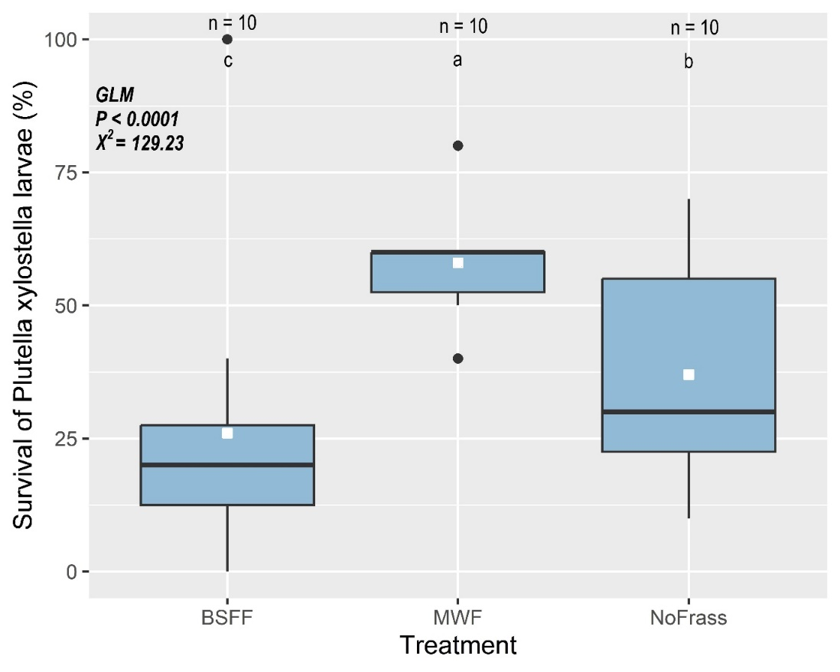

**Figure 5.** Survival of *Plutella xylostella* larvae on *B. rapa* grown in unamended soil (NoFrass; control) or soil amended with raw BSF frass (BSFF) or raw yellow mealworm frass (MWF). Boxplots show the median (horizontal bold line), and minimum and maximum values. The dots represent outliers. The white square on each box represents the mean larval survival per plant. Data were analysed by generalised linear models (GLM). n is the number of replicates per treatment. Boxes with different letters are significantly different (Tukey's post hoc test, *p* < 0.05).

**Effect of raw frass on feeding damage by *Plutella xylostella* larvae on *Brassica rapa* plants**

Soil amendment with raw frass did not affect larval feeding damage on the leaves of *B. rapa* plants (*χ2* = 2.46; df = 2; *p* = 0.2931; Figure S8A). A marginally different larval feeding damage was recorded when the experiment was repeated under similar conditions (*χ2* = 5.40; df = 2; *p* = 0.0672; Figure S8B).

**Effects of incubated and composted frass on the growth of *Brassica rapa* plants**

BSFF or MWF that had been incubated in the soil for 16 days significantly affected the growth of *B. rapa* plants (*χ2* = 32.36; df = 2; *p* < 0.0001; Figure 6A). Compared to the control (NoFrass) and BSFF, incubating MWF in the soil resulted in the highest mean leaf area (Figure 6A). Plants exposed to incubated BSFF had a similar leaf area as plants exposed to the NoFrass control. When BSFF or MWF was composted before being added to the soil this also affected leaf area (*χ2* = 13.15; df = 2; *p* = 0.0014; Figure 6B). Amending the soil with composted BSFF resulted in the lowest mean leaf area, which was significantly different from plants grown in composted MWF. Neither composted BSFF nor composted MWF resulted in a leaf number significantly different from plants exposed to the control (Figure 6B).

The number of leaves per *B. rapa* plant was not affected by incubated BSFF or MWF (*χ2* = 2.10; df = 2; *p* = 0.3506; Figure S9A). However, both composted BSFF and composted MWF significantly increased the number of leaves per plant (*χ2* = 17.65; df = 2; *p* = 0.0002; Figure S9B), with the highest value for MWF and the lowest for NoFrass (Figure S9B).

The time until the start of flowering was not significantly affected by the incubation of frass in the soil when compared to the Nofrass control (*χ2*= 0.13; df = 2; *p* = 0.9355; Figure S10A). Similarly, the time until flowering of *B. rapa* plants did not differ significantly when either BSFF or MWF was composted before being added to the soil (*χ2*= 0.26; df = 2; *p* = 0.8782; Figure S10B).

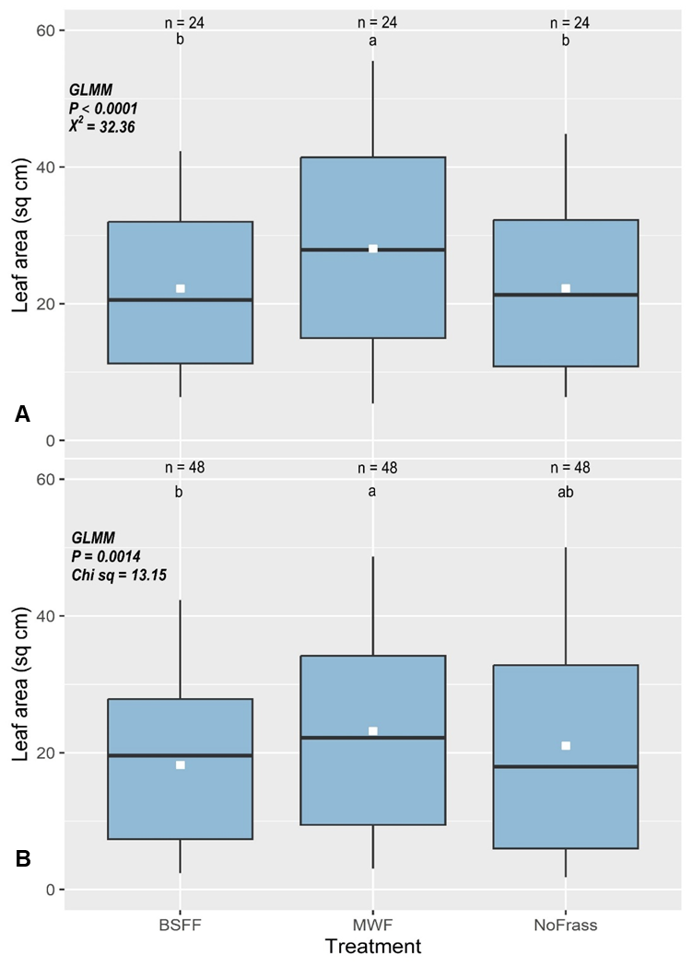

**Figure 6**. Leaf area (sq cm) of *B. rapa* grown on soil either amended or not amended (NoFrass; control): (A) by incubating; (B) with composted BSF frass (BSFF) or yellow mealworm frass (MWF). Incubation involved frass mixed with soil in 0.5 L plastic pots and moistened, and seeds were only sown after sixteen days under greenhouse conditions. Boxplots show the median (horizontal bold line), and minimum and maximum values. The white square on each box represents the mean leaf area per plant. Data were analysed with a generalised linear mixed effect model (GLMM). n is the number of measurements per treatment. Boxes with different letters are significantly different (Tukey's post hoc test, *p* < 0.05).

**Discussion**

We investigated the effect of soil amendment with raw black soldier fly frass (BSFF) and mealworm frass (MWF) on the growth of *B. rapa* plants and the survival and development of the diamondback moth (*P. xylostella*) and cabbage root fly (*D. radicum*). Our results showed that amending soil with BSFF and MWF resulted in smaller leaf area, fewer leaves, and longer time until flowering compared to the NoFrass control. Soil amendment with BSFF resulted in the lowest survival and biomass of *D. radicum* larvae and pupae respectively, while MWF resulted in the highest larval survival and biomass. Similarly, soil amendment with BSFF resulted in a lower survival rate of *P. xylostella* larvae compared to the control and MWF. Larval feeding damage on the leaves of *B. rapa* plants was not significantly affected by frass treatments. Interestingly, when frass was incubated in the soil or composted before being added to the soil, it significantly affected the growth of *B. rapa* plants. Specifically, the growth inhibition that was previously observed for raw BSFF and MWF had been eliminated.

The plant growth inhibition by raw frass in our study is consistent with previous studies. For example, maize plant growth trials showed that soil amendment with BSFF resulted in stunted growth, fewer plant leaves, smaller leaf area, and showed lower nitrogen use efficiencies (Alattar et al., 2016; Gärttling et al., 2020). Recently, research on *B. oleracea* grown in soil amended with BSFF revealed a decrease in dry shoot biomass compared to a synthetic fertiliser (Wantulla et al., 2022). In a growth trial of barley plants, the application of MWF alone did not increase plant biomass and nutrient uptake. However, when the frass was applied in combination with a synthetic N-P-K fertiliser, it did lead to an increase in both of these factors (Houben et al., 2020).Contrary to our results, studies have demonstrated that combining BSFF with synthetic fertilisers improves rice plant growth (Reswita et al., 2022; Zim et al., 2022). Dzepe et al. found that lettuce plants grew better in soil that had been amended with BSFF than in soil that had been fertilised with urea or left unamended (Dzepe et al., 2022). Another study found that compared to unamended sandy soil, zucchini plants grown in BSFF- and MWF-treated soil had considerably taller plants, bigger leaf area, and higher dry leaf weights (Zim et al., 2022).

A probable explanation for the negative effect of raw frass on plant growth in the current study is that the frass used might have contained compounds that are toxic to plants. Moreover, frass quality depends heavily on the larval substrate as well as the postharvest processing. Growth-inhibition by heavy metal accumulation particularly cadmium in plant tissues has been found (John et al., 2009; Kycko et al., 2019; Saadaoui et al., 2022). The negative growth effects may have been due to cadmium's inhibition of the proton pump implicated in cellular plant growth (Kycko et al., 2019; Reswita et al., 2022; Zim et al., 2022). However, this study cannot confirm the effect of heavy metals because it was not tested. Furthermore, soil amendment with frass in this study might have altered the physical properties of the soil and obstructed root growth. Excess frass in the soil can lead to soil compaction or waterlogging, which can limit the availability of oxygen and other essential nutrients to plant roots (Liu et al., 2019). This would require further studies to confirm since only a single frass dose was used in the current study. Alternatively, frass salinity may affect its performance. For example, high salt content can disrupt the delicate balance of ions and nutrients in the soil, leading to imbalances that are harmful to plant growth (Zhang et al., 2012). It should be noted that the quality of the raw frass used in this study may have been impacted by the extended heat treatment (24 hr at 60°C) compared to the shorter duration of 1 hr at 70°C required by the EU Commission regulation EU 2021/1925, and confirmed by Van Looveren et al.'s (2021) study, which assessed the effects of this heat treatment on BSFF (Van Looveren et al., 2021). The application of raw BSFF resulted in a longer time until flowering compared to MWF and the NoFrass control. However, when the experiment was repeated under similar conditions, no significant effect of soil treatment on time until flowering was observed. Overall, these findings suggest that the use of raw BSFF or raw MWF as soil amendments may have negative effects on the growth and flowering of *B. rapa* plants, particularly in terms of leaf production. However, the effect on time until flowering may be more variable and may depend on specific experimental conditions. The disparities between the effects of raw frass in the current study and the positive results reported in other previous studies illustrate the difficulty in generalising the effect of frass as an organic fertiliser on crop growth performance.

Pests of cruciferous plants, especially Brassicas, include *Delia radicum* and *Plutella xylostella*. *Delia radicum* larvae feed on plant roots, but *P. xylostella* larvae feed on plant leaves, resulting in severe reductions in plant growth and yield. In our study, amending soil with raw BSFF resulted in a significant decrease in the survival rate of *D. radicum* larvae and *P. xylostella* larvae. Similarly, soil amendment with raw BSFF resulted in the lowest *D. radicum* pupal biomass, while MWF resulted in the highest pupal biomass. These findings suggest that biomolecules such as chitin present in the frass were able to effectively control the populations of *D. radicum* larvae in the soil, and *P. xylostella* larvae feeding on the leaves of *B. rapa*. However, it is important to note that the effectiveness of BSFF as a pest control method may vary depending on the specific properties of the frass and soil used. While the activation of plant defensive responses following frass amendments has been attributed to the presence of eliciting molecules or microorganisms (Poveda, 2021), the particular mechanisms responsible for the lower herbivore performance in soil amendments with raw BSFF in the current study are unknown. Further research is needed to investigate the mechanisms behind the insecticidal effects of these soil amendments and their potential as pest management tools in agriculture.

Our findings suggest that soil amendment with raw frass did not have a significant impact on the damage caused by *P. xylostella* larvae feeding on the leaves of *B. rapa* plants. Nonetheless, it is worth mentioning that when the experiment was repeated under similar conditions, a marginally different result was recorded, which suggests a trend towards a significant difference between the treatments. Therefore, additional research is required to verify whether there is a true effect of soil amendment with raw frass on larval feeding damage to the leaves of *B. rapa* plants.

Intriguingly, amending soil with raw MWF resulted in higher herbivore performance than raw BSFF amendment. When the experiments were repeated under similar conditions, comparable results were obtained, reinforcing the reliability of the findings and suggests that the effect of raw BSFF or raw MWF treatments on the survival of *D. radicum* larvae is consistent and not dependent on the specific experimental conditions. We hypothesised that the addition of frass to the soil would reduce herbivore performance by releasing biomolecules and cues that alter plant defenses against herbivorous insect pests (Barragán-Fonseca et al., 2022; Ray et al., 2015). However, it appears that the addition of MWF to the soil may have altered the chemical composition of the frass or the soil to extents that favoured the survival and biomass accumulation in root-feeding *D. radicum* larvae and provided better and readily available plant nutrition forleaf-feeding *P. xylostella* larvae. For instance, a short-term pot experiment alluded a high mineralisation of MWF particularly at higher rates of application (Houben et al., 2021). A field study on compost and vermicompost and their ability to reduce heavy metal availability in contaminated soils showed decreased heavy metals in the soil and suggested heavy metal immobilisation by humic substances from the organic amendments (Angelova et al., 2013). In addition, the MWF may have altered the soil microbial community, potentially favouring the growth of microorganisms that are more beneficial to the root-feeding insect herbivore larvae. It's also possible that the MWF used in our study may not have had the same chemical composition as other sources of insect frass that have been shown to induce plant defenses (Poveda et al., 2019). Different insect species produce different types and amounts of defensive compounds, so the composition of the insect frass can vary depending on the insect species used (Ray et al., 2016). A greenhouse experiment to measure frass-induced plant defences of maize, rice, cabbage and tomato plants showed that caterpillar frass-induced plant defenses are specific to each host-herbivore system and can induce herbivore or pathogen defence responses in the host plant depending on the composition of the frass deposited, the plant organ where it is deposited, and the insect species (Poveda, 2021; Ray et al., 2016). However, another study found that herbivore performance on maize plants was enhanced due to biochemical cues that suppressed herbivore defences (Ray et al., 2015). Overall, these findings suggest that soil amendment with raw BSFF, at least under the conditions tested in this study, may have a detrimental effect on the survival of *D. radicum* larvae, while the use of raw MWF may have protective effect against root infestation. However, the mechanisms that underpin these results and the factors that may have promoted herbivore performance in raw mealworm frass amendment need more studies. The results of our present study align with certain prior research, while contradicting others, as anticipated because of the differences in the frass origins and quality employed in our study and those conducted earlier. This discrepancy highlights the need for additional research to explain the findings and broaden our understanding of the potential of frass application for soil enhancement and plant growth promotion.

A fascinating and potentially beneficial finding from our present study is that the process of incubating and composting raw frass prevented the inhibition of plant growth. Incubating MWF in the soil before sowing *B. rapa* seeds resulted in a larger leaf area for the plants compared to the NoFrass control. Furthermore, both composted BSFF and MWF significantly increased the number of leaves per plant, with the highest value for MWF. Frass contains macronutrients like nitrogen, phosphate, and potassium, micronutrients, and beneficial microbes. Adding frass to the soil makes these nutrients more readily available to the plants, which in turn may improve plant growth (Gärttling & Schulz, 2022; Gebremikael et al., 2022; Houben et al., 2020; Poveda, 2021; Poveda et al., 2019). The use of organic fertilisers like animal manure and compost has been found to increase soil fertility and plant growth, which is consistent with our finding. Using organic fertilisers has been shown to improve plant growth and yield by increasing soil organic matter, nutrient availability, and water-holding capacity (Bashir et al., 2021; Rayne & Aula, 2020). In all, it seems probable that the incubation of frass, particularly MWF, in the soil before planting *B. rapa* seeds enhanced plant growth in our study. This could be attributed to various potential benefits of frass incubation such as increased nutrient availability, better soil structure, and the existence of microorganisms beneficial to plant growth and health (Ahmad et al., 2016). Interestingly, the incubation of frass in the soil did not significantly affect the time until the flowering or the time until flowering of *B. rapa* plants. This suggests that the effects of frass on plant growth and development may be more pronounced during the vegetative stage of growth than during the reproductive stage. It is worth noting that the effects of frass on plant growth and development may be influenced by a variety of factors, such as the type and amount of frass, the plant species, and the environmental conditions. Therefore, caution should be taken when extrapolating these results to other systems or contexts.

A limitation of the current study is that while we tested the effects of raw frass on both plant growth and herbivore performance, we only tested the effects of incubated and composted frass on plant growth. This means that we do not have a complete understanding of the effects of these different types of frass on herbivore performance. In future studies, it would be important to include measurements of herbivore performance when testing the effects of different types of frass on plant growth. Additionally, it would be interesting to explore the potential mechanisms behind the observed effects, such as changes in soil nutrient availability or the presence of beneficial microorganisms in the frass. Moreover, assessing feeding damage by larvae of *D. radicum* on plants grown in soil amended with frass in future studies would provide another dimension of the potential role of insect residual streams on herbivore control.

**Conclusions**

This study has shown that the use of raw BSFF and MWF have the potential as alternative sources of organic fertilisers for sustainable agriculture. However, the use of raw BSFF may also have implications for insect herbivore control, as it decreases the performance of *D. radicum* and *P. xylostella* larvae. In contrast, the use of raw MWF increases the survival of these pests. The lack of a significant effect of soil amendments on leaf feeding *P. xylostella* larvae suggests that other factors, such as the presence of natural predators or the use of physical barriers, may be more effective in controlling this pest. Additionally, the effect of incubating and composting frass on plant growth performance highlights the importance of proper handling and treatment of frass to maximize its potential benefits. The current study indicates that it may be more effective to incubate the frass in the soil before sowing the seeds, allowing frass nutrients to become more readily available to the plants and potentially leading to better plant growth. These findings suggest that a holistic approach, combining the use of frass as a sustainable fertiliser with other pest management strategies, may be necessary to achieve sustainable agriculture practices. Future studies should compare the effects of raw frass, incubated and composted frass, particularly BSFF on insect herbivores, and the mechanisms of action to understand their potential for sustainable herbivore control.

**Funding**

This work was funded by Wageningen University & Research through the Africa Talent Programme (ATP).

**Declaration of conflict of interest**

The authors report financial support from and affiliation with Wageningen University and Research.

**Supplementary material**

**Table S1.** Summary of *Brassica rapa* seed germination for the four trials.

|  |  |  |  |  |  |  |
| --- | --- | --- | --- | --- | --- | --- |
| Trial | Seeds sown | Seeds germinated | % Seed germination | Time (days) | Seed treatment | Germination method |
| 1 | 120 | 114 | 95.0 | 1-3 | stratified | germinated in unamended soil |
| 2 | 160 | 146 | 91.3 | 1-3 | stratified | germinated in unamended soil |
| 3 | 36 | 32 | 88.9 | 1-3 | stratified | Sown directly into amended soil |
| 4 | 51 | 45 | 88.2 | 1.3 | stratified | Sown directly into amended soil |

Seeds were stratified by maintaining them in moist filter papers in Petri dishes at 4 °C for 7 days. Trials 1 and 2: raw frass (no incubation or composting); Trial 3: frass incubated in the soil before seeds were sown; Trial 4: frass samples were composted, air-dried and pulverised before being added to the soil. Data were analysed with a using the Chi-squared test.

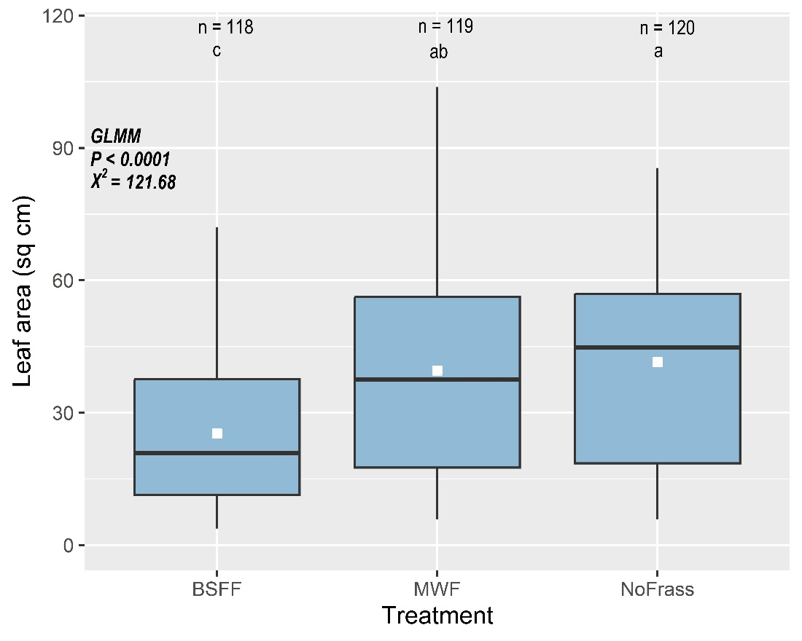

**Figure S1**. Leaf area (sq cm) of *B. rapa* plants grown in unamended soil (NoFrass; control) or soil amended with raw BSF frass (BSFF) or raw yellow mealworm frass (MWF). Boxplots show the median (horizontal bold line), and minimum and maximum values. The white square on each box represents the mean leaf area per plant. Data were analysed with a generalised linear mixed effect model (GLMM). n is the number of measurements per treatment. Boxes with different letters are significantly different (Tukey's post hoc test, *p* < 0.05).

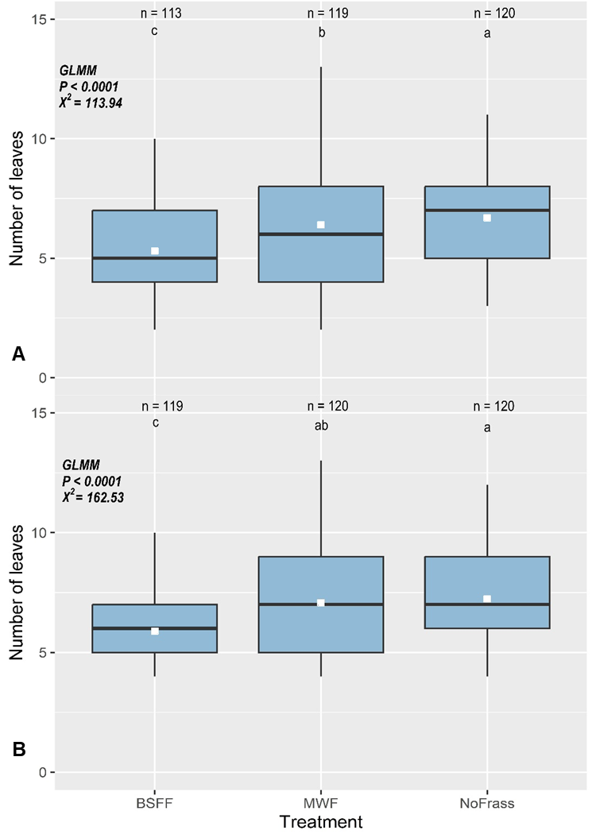

**Figure S2**. Number of leaves of *B. rapa* plants grown in unamended soil (NoFrass; control) or soil amended with raw BSF frass (BSFF) or raw yellow mealworm frass (MWF). A = trial 1 and B = trial 2. Control plants grew in soil without amendment (NoFrass). Boxplots show the median (horizontal bold line), and minimum and maximum values. The white square on each box represents the mean number of leaves per plant. Data were analysed by generalised linear mixed effect models (GLMM). n is the number of measurements per treatment. Boxes with different letters are significantly different (Tukey's post hoc test, *p* < 0.05).

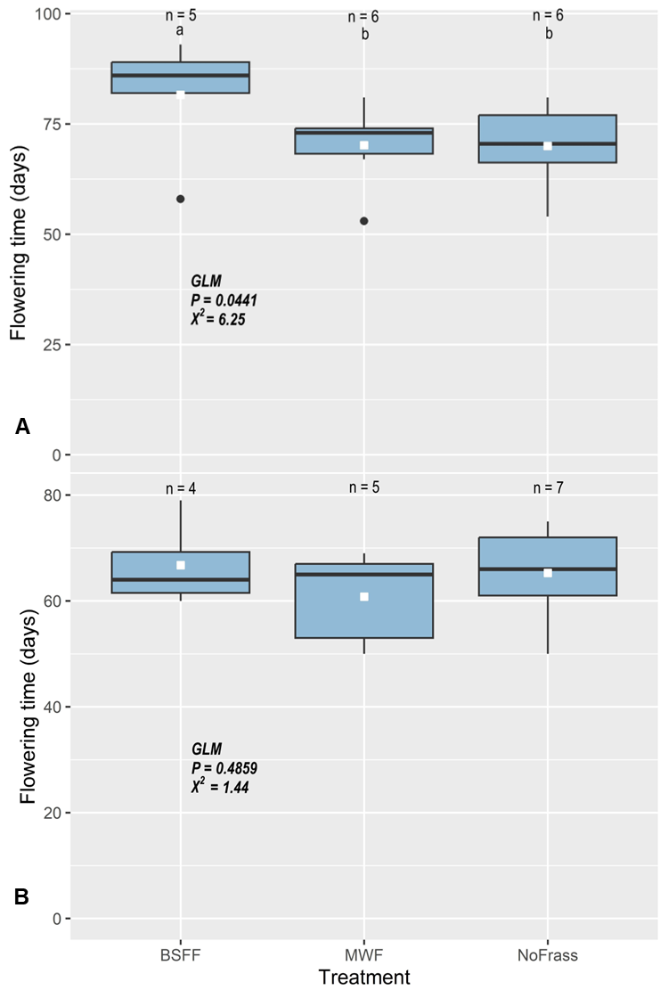

**Figure S3**. Time until flowering(days) of *B. rapa* grown in unamended soil (NoFrass; control) or soil amended with raw BSF frass (BSFF) or raw yellow mealworm frass (MWF) in two trials. A = trial 1 and B = trial 2. Boxplots show the median (horizontal bold line), and minimum and maximum values. The dots represent outliers. The white square on each box represents the mean time until flowering per treatment. Data were analysed with a generalised linear model (GLM). n is the number of replicate plants. Boxes with different letters are significantly different (Fisher's Least Significant Difference post hoc test, *p* < 0.05).

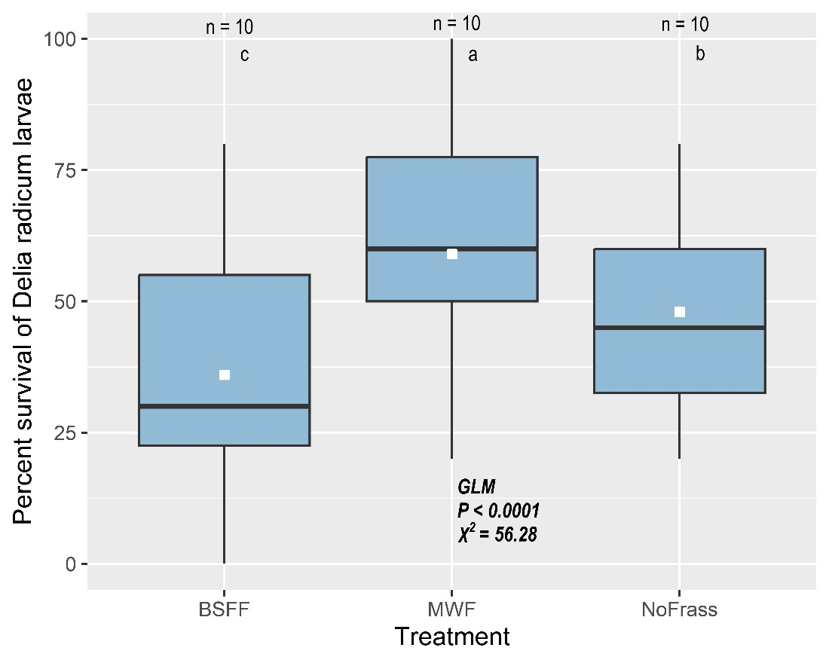

**Figure S4.** Survival of *Delia radicum* larvae on roots of *B. rapa* plants grown in unamended soil (NoFrass; control) or soil amended with raw BSF frass (BSFF) or raw yellow mealworm frass (MWF). Boxplots show the median (horizontal bold line), and minimum and maximum values. The white square on each box represents the mean larval survival. Data were analysed by generalised linear models (GLM). n is the number of replicates. Boxes with different letters are significantly different (Tukey's post hoc test, *p* < 0.05).

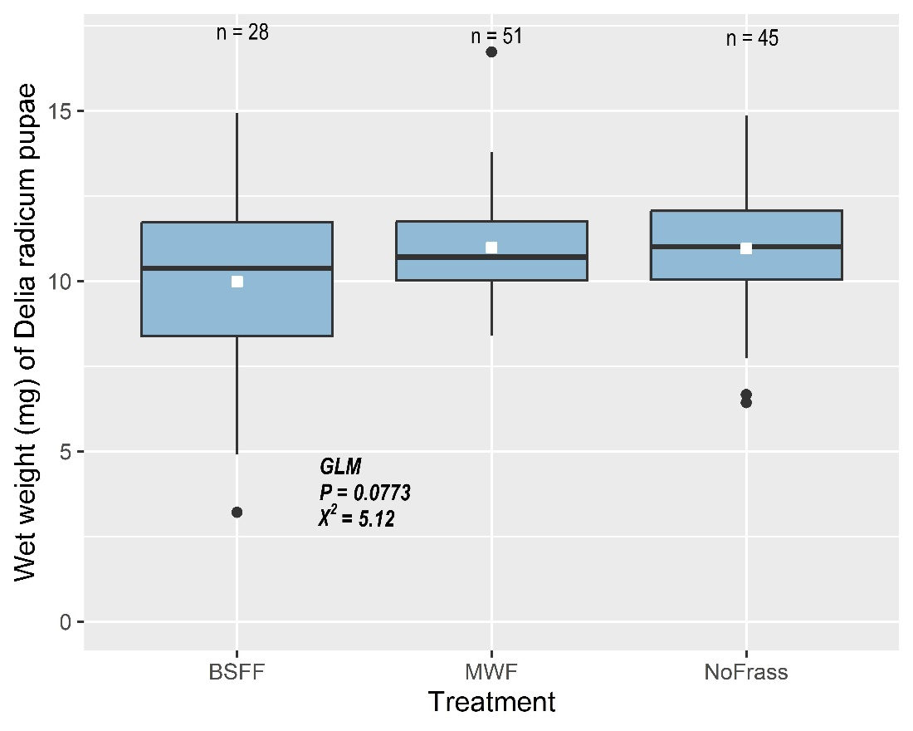

**Figure S5.** Biomass (mg) of *Delia radicum* pupae retrieved after a 21-day root infestation of *B. rapa* grown in unamended soil (NoFrass; control) or soil amended with raw BSF frass (BSFF) or raw yellow mealworm frass (MWF). Boxplots show the median (horizontal bold line), and minimum and maximum values. The dots represent outliers. The white square on each box represents the mean pupal weight. Data were analysed with generalised linear models (GLM). n is the number of pupae weighed.

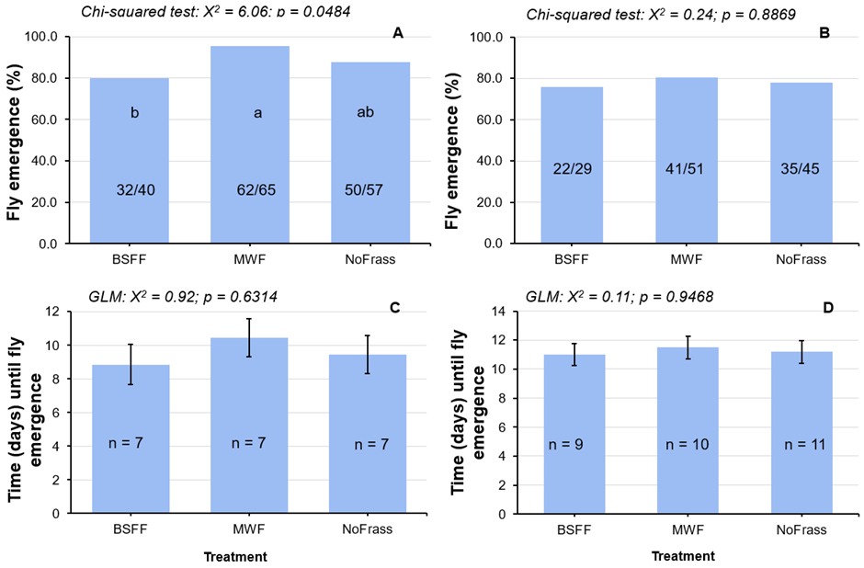

**Figure S6.** Emergence of *Delia radicum* adult flies after pupae were retrieved from the roots of *B. rapa* grown in unamended soil (NoFrass; control) or soil amended with raw BSF frass (BSFF) or raw yellow mealworm frass (MWF). A = proportion (%) of flies that emerged during the first trial (trial 1), B = proportion (%) of flies that emerged during the second trial (trial 2), C = time (mean ± S.E) until fly emergence during trial 1, and D = time (mean ± S.E) until fly emergence during trial 2. Data on the proportion of flies that emerged were analysed with the chi-squared test equality of proportions. The fractions (32/40, 62/65, 50/57, 22/29, 41/51 and 35/45) on the graph show the proportion of flies that emerged (numerator) out of the number of pupae (denominator). Data on time until fly emergence were analysed with a generalised linear model (GLM). n is the number of replicates. Error bars represent standard errors of the average time until emergence. Bars with different letters are significantly different following the Marascuilo procedure as a post hoc test (the absolute pairwise difference between proportions is statistically significant if its value exceeds the critical range value). Graphs without error bars represent single measurements (proportions).

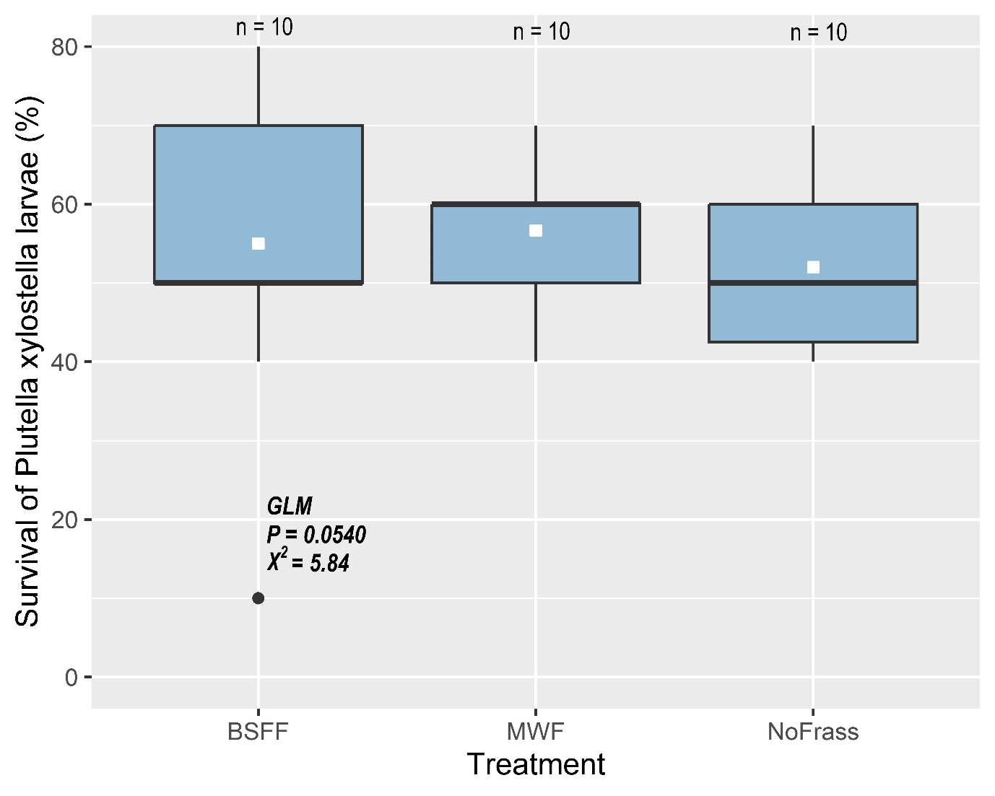

**Figure S7.** Survival (%) of *Plutella xylostella* larvae on *B. rapa* grown in unamended soil (NoFrass; control) or soil amended with raw BSF frass (BSFF) or raw yellow mealworm frass (MWF). Boxplots show the median (horizontal bold line), and minimum and maximum values. The dot represents an outlier. The white square on each box represents the mean larval survival per plant. Data were analysed with a generalised linear model (GLM). n is the number of replicates.

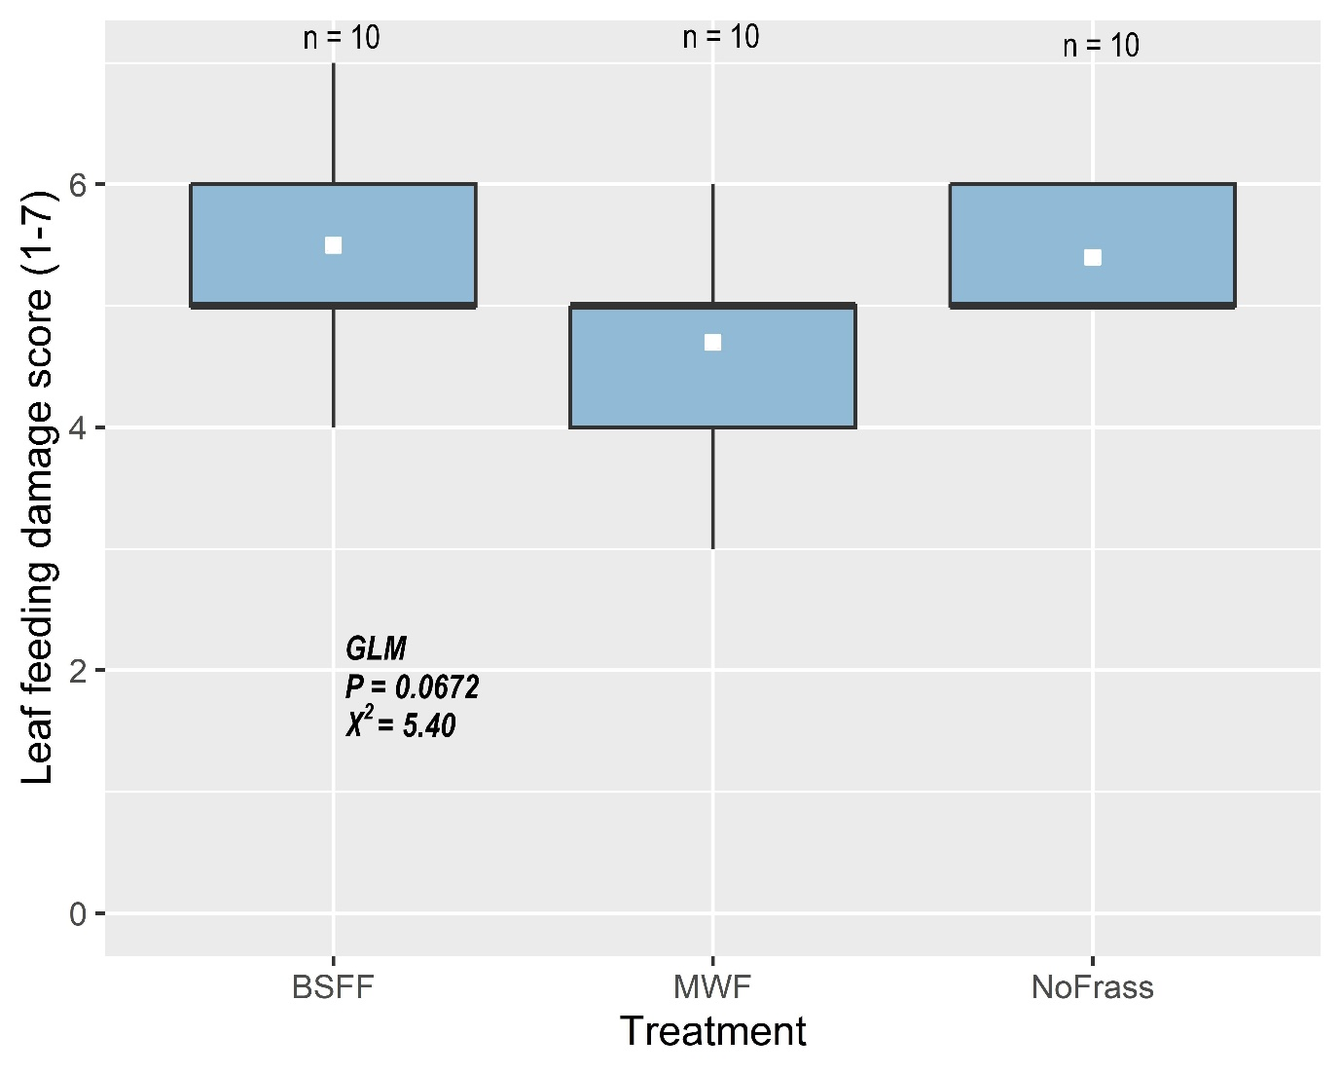

**Figure S8.** Feeding damage (scores) by larvae of *Plutella xylostella* on *B. rapa* grown in unamended soil (NoFrass; control) or soil amended with raw BSF frass (BSFF) or raw yellow mealworm frass (MWF) in two trials. A = trial 1 and B = trial 2. Boxplots show the median (horizontal bold line), and minimum and maximum values. The white square on each box represents the mean feeding damage. Data were analysed with a generalised linear model (GLM). n is the number of replicates.

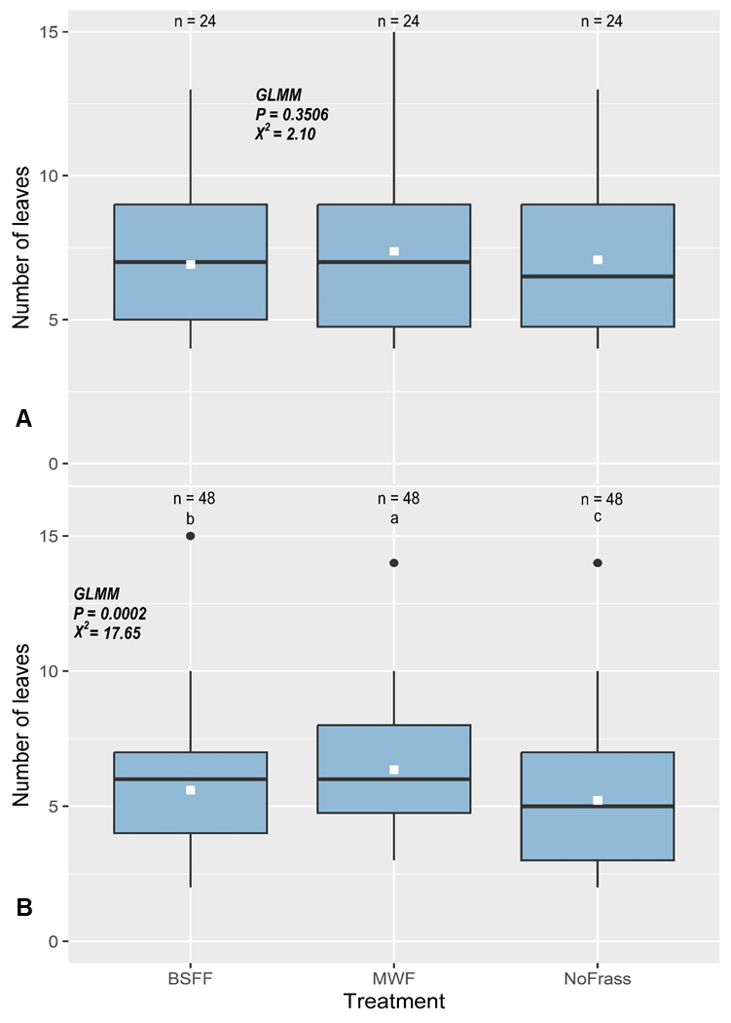

**Figure S9**. Number of leaves of *B. rapa* grown in soil either amended or not amended (NoFrass; control): by incubating; with composted BSF frass (BSFF) or yellow mealworm frass (MWF). A = frass was incubated in the soil before seeds were sown and, B = frass was composted before being added to the soil. Incubation involved frass mixed with soil in 0.5 L plastic pots and moistened, and seeds were only sown after sixteen days under greenhouse conditions. Boxplots show the median (horizontal bold line), and minimum and maximum values. The dots outliers. The white square on each box represents the mean number of leaves. Data were analysed with a generalised linear mixed effect model (GLMM). n is the number of replicates. Boxes with different letters are significantly different (Tukey's post hoc test, *p* < 0.05).

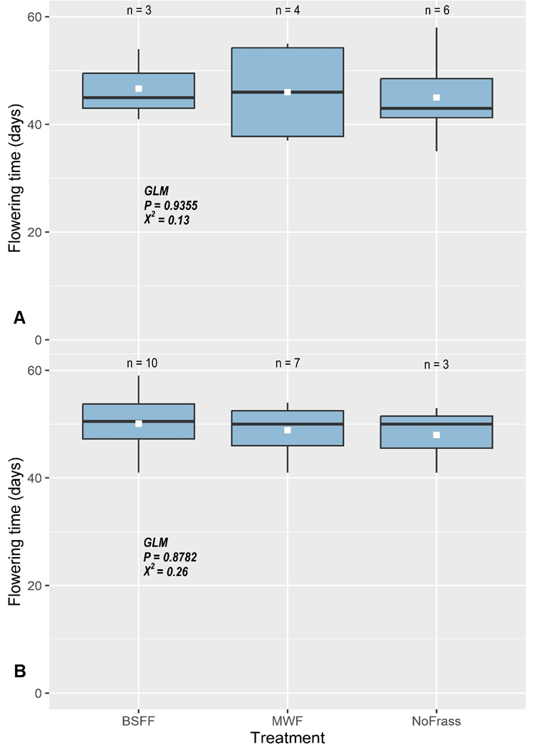

**Figure S10.** Time until flowering (days) of *B. rapa* grown soil either amended or not amended (NoFrass; control): by incubating; with composted BSF frass (BSFF) or yellow mealworm frass (MWF). A = frass was incubated in the soil before seeds were sown and, B = frass was composted before being added to the soil. Boxplots show the median (horizontal bold line), and minimum and maximum values. The white square on each box represents the mean flowering time. Data were analysed with a generalised linear model (GLM). n is the number of replicates.

**References**

Abiya, A. A., Kupesa, D. M., Beesigamukama, D., Kassie, M., Mureithi, D., Thairu, D., Wesonga, J., Tanga, C. M., & Niassy, S. (2022). Agronomic Performance of Kale (Brassica oleracea) and Swiss Chard (Beta vulgaris) Grown on Soil Amended with Black Soldier Fly Frass Fertilizer under Wonder Multistorey Gardening System. *Agronomy*, *12*(9), 2211.

Adedia, D., Asem, L., Appiah, S. K., Nanga, S., Boateng, Y., Duedu, K. O., & Anani, L. (2020). Assessment of hypertension-induced deaths in Ghana: a nation-wide study from 2012 to 2016. *Journal of Data Analysis and Information Processing*, *8*(03), 158.

Ahmad, A. A., Radovich, T. J., Nguyen, H. V., Uyeda, J., Arakaki, A., Cadby, J., Paull, R., Sugano, J., & Teves, G. (2016). Use of organic fertilizers to enhance soil fertility, plant growth, and yield in a tropical environment. *Organic Fertilizers-From Basic Concepts to Applied Outcomes*, 85-108.

Ahuja, I., Rohloff, J., & Bones, A. M. (2010). Defence mechanisms of Brassicaceae: implications for plant-insect interactions and potential for integrated pest management. A review. *Agronomy for Sustainable Development*, *30*(2), 311-348. https://doi.org/10.1051/agro/2009025

Alattar, M. A., Alattar, F. N., & Popa, R. (2016). Effects of microaerobic fermentation and black soldier fly larvae food scrap processing residues on the growth of corn plants (Zea mays). *Plant Science Today*, *3*(1), 57-62.

Angelova, V., Akova, V., Artinova, N., & Ivanov, K. (2013). The effect of organic amendments on soil chemical characteristics. *Bulgarian Journal of Agricultural Science*, *19*(5), 958-971.

Barragán-Fonseca, K. Y., Nurfikari, A., van de Zande, E. M., Wantulla, M., van Loon, J. J. A., de Boer, W., & Dicke, M. (2022). Insect frass and exuviae to promote plant growth and health. *Trends Plant Sci*, *27*(7), 646-654. https://doi.org/10.1016/j.tplants.2022.01.007

Bashir, S., Bakhsh Gulshan, A., Iqbal, J., Husain, A., Alwahibi, M. S., Alkahtani, J., Dwiningsih, Y., Bakhsh, A., Ahmed, N., Jamal Khan, M., Ibrahim, M., & Diao, Z.-H. (2021). Comparative role of animal manure and vegetable waste induced compost for polluted soil restoration and maize growth. *Saudi journal of biological sciences*, *28*(4), 2534-2539. https://doi.org/https://doi.org/10.1016/j.sjbs.2021.01.057

Basri, N. E. A., Azman, N. A., Ahmad, I. K., Suja, F., Jalil, N. A. A., & Amrul, N. F. (2022). Potential Applications of Frass Derived from Black Soldier Fly Larvae Treatment of Food Waste: A Review. *Foods*, *11*(17), 2664. https://www.mdpi.com/2304-8158/11/17/2664

Basu, A., Prasad, P., Das, S. N., Kalam, S., Sayyed, R., Reddy, M., & El Enshasy, H. (2021). Plant growth promoting rhizobacteria (PGPR) as green bioinoculants: recent developments, constraints, and prospects. *Sustainability*, *13*(3), 1140.

Bates, D., Mächler, M., Bolker, B., & Walker, S. (2014). Fitting linear mixed-effects models using lme4. *arXiv preprint arXiv:1406.5823*.

Berendsen, R. L., Pieterse, C. M., & Bakker, P. A. (2012). The rhizosphere microbiome and plant health. *Trends Plant Sci*, *17*(8), 478-486. https://doi.org/10.1016/j.tplants.2012.04.001

Chen, Y., Olson, D. M., & Ruberson, J. R. (2010). Effects of nitrogen fertilization on tritrophic interactions. *Arthropod-Plant Interactions*, *4*, 81-94.

Chia, S. Y., Tanga, C. M., Osuga, I. M., Cheseto, X., Ekesi, S., Dicke, M., & van Loon, J. J. (2020). Nutritional composition of black soldier fly larvae feeding on agro‐industrial by‐products. *Entomologia Experimentalis et Applicata*, *168*(6-7), 472-481.

Chia, S. Y., Tanga, C. M., van Loon, J. J., & Dicke, M. (2019). Insects for sustainable animal feed: inclusive business models involving smallholder farmers. *Current Opinion in Environmental Sustainability*, *41*, 23-30.

Choi, S., & Hassanzadeh, N. (2019). BSFL Frass: A novel biofertilizer for improving plant health while minimizing environmental impact. *Candian Sci. Fair J*, *2*, 41-46.

Dzepe, D., Mbenda, T. K., Ngassa, G., Mube, H., Chia, S. Y., Aoudou, Y., & Djouaka, R. (2022). Application of Black Soldier Fly Frass, Hermetia illucens (Diptera: Stratiomyidae) as Sustainable Organic Fertilizer for Lettuce, Lactuca sativa Production. *Open Journal of Applied Sciences*, *12*(10), 1632-1648.

Fox, J., Weisberg, S., Adler, D., Bates, D., Baud-Bovy, G., Ellison, S., Firth, D., Friendly, M., Gorjanc, G., & Graves, S. (2012). Package ‘car’. *Vienna: R Foundation for Statistical Computing*, *16*.

Frost, C. J., & Hunter, M. D. (2004). INSECT CANOPY HERBIVORY AND FRASS DEPOSITION AFFECT SOIL NUTRIENT DYNAMICS AND EXPORT IN OAK MESOCOSMS. *Ecology*, *85*(12), 3335-3347. https://doi.org/https://doi.org/10.1890/04-0003

Gadhave, K. R., Finch, P., Gibson, T. M., & Gange, A. C. (2016). Plant growth-promoting Bacillus suppress Brevicoryne brassicae field infestation and trigger density-dependent and density-independent natural enemy responses. *Journal of Pest Science*, *89*, 985-992.

Gärttling, D., Kirchner, S. M., & Schulz, H. (2020). Assessment of the N-and P-fertilization effect of black soldier fly (Diptera: Stratiomyidae) by-products on maize. *Journal of Insect Science*, *20*(5), 8.

Gärttling, D., & Schulz, H. (2022). Compilation of black soldier fly frass analyses. *Journal of Soil Science and Plant Nutrition*, *22*(1), 937-943.

Gebremikael, M. T., van Wickeren, N., Salehi Hosseini, P., & De Neve, S. (2022). The impacts of black soldier Fly Frass on nitrogen availability, microbial activities, C sequestration, and plant growth. *Frontiers in Sustainable Food Systems*, *6*.

Houben, D., Daoulas, G., & Dulaurent, A.-M. (2021). Assessment of the short-term fertilizer potential of mealworm frass using a pot experiment. *Frontiers in Sustainable Food Systems*, *5*, 714596.

Houben, D., Daoulas, G., Faucon, M.-P., & Dulaurent, A.-M. (2020). Potential use of mealworm frass as a fertilizer: Impact on crop growth and soil properties. *Scientific Reports*, *10*(1), 1-9.

Hu, L., Robert, C. A. M., Cadot, S., Zhang, X., Ye, M., Li, B., Manzo, D., Chervet, N., Steinger, T., van der Heijden, M. G. A., Schlaeppi, K., & Erb, M. (2018). Root exudate metabolites drive plant-soil feedbacks on growth and defense by shaping the rhizosphere microbiota. *Nature Communications*, *9*(1), 2738. https://doi.org/10.1038/s41467-018-05122-7

John, R., Ahmad, P., Gadgil, K., & Sharma, S. (2009). Heavy metal toxicity: Effect on plant growth, biochemical parameters and metal accumulation by Brassica juncea L.

Klammsteiner, T., Turan, V., Fernández-Delgado Juárez, M., Oberegger, S., & Insam, H. (2020). Suitability of Black Soldier Fly Frass as Soil Amendment and Implication for Organic Waste Hygienization. *Agronomy*, *10*(10), 1578. https://www.mdpi.com/2073-4395/10/10/1578

Kycko, M., Romanowska, E., & Zagajewski, B. (2019). Lead-Induced Changes in Fluorescence and Spectral Characteristics of Pea Leaves. *Remote Sensing*, *11*(16), 1885. https://www.mdpi.com/2072-4292/11/16/1885

Lenth, R., & Lenth, M. R. (2018). Package ‘lsmeans’. *The American Statistician*, *34*(4), 216-221.

Lopes, I. G., Yong, J. W., & Lalander, C. (2022). Frass derived from black soldier fly larvae treatment of biodegradable wastes. A critical review and future perspectives. *Waste Management*, *142*, 65-76.

Mahapatra, S., Yadav, R., & Ramakrishna, W. (2022). Bacillus subtilis impact on plant growth, soil health and environment: Dr. Jekyll and Mr. Hyde. *Journal of Applied Microbiology*, *132*(5), 3543-3562.

Mariod, A. A. (2020). Nutrient composition of mealworm (Tenebrio molitor). *African Edible Insects as Alternative Source of Food, Oil, Protein and Bioactive Components*, 275-280.

Martinez, D. A., Loening, U. E., Graham, M. C., & Gathorne-Hardy, A. (2021). When the Medicine Feeds the Problem; Do Nitrogen Fertilisers and Pesticides Enhance the Nutritional Quality of Crops for Their Pests and Pathogens? *Frontiers in Sustainable Food Systems*, *5*, 701310.

Nicolopoulou-Stamati, P., Maipas, S., Kotampasi, C., Stamatis, P., & Hens, L. (2016). Chemical pesticides and human health: the urgent need for a new concept in agriculture. *Frontiers in public health*, *4*, 148.

Niemann, J., Szwarc, J., Bocianowski, J., Weigt, D., & Mrówczyński, M. (2020). In-field screening for host plant resistance to Delia radicum and Brevicoryne brassicae within selected rapeseed cultivars and new interspecific hybrids. *Open Life Sciences*, *15*(1), 711-720.

Nurfikari, A., & de Boer, W. (2021). Chitin determination in residual streams derived from insect production by LC-ECD and LC-MS/MS methods. *Frontiers in Sustainable Food Systems*, 493.

Pangesti, N., Pineda, A., Pieterse, C. M., Dicke, M., & Van Loon, J. J. (2013). Two-way plant mediated interactions between root-associated microbes and insects: from ecology to mechanisms. *Frontiers in Plant Science*, *4*, 414.

Pineda, A., Zheng, S. J., van Loon, J. J., Pieterse, C. M., & Dicke, M. (2010). Helping plants to deal with insects: the role of beneficial soil-borne microbes. *Trends Plant Sci*, *15*(9), 507-514. https://doi.org/10.1016/j.tplants.2010.05.007

Poveda, J. (2021). Insect frass in the development of sustainable agriculture. A review. *Agronomy for Sustainable Development*, *41*(1), 1-10.

Poveda, J., Jiménez-Gómez, A., Saati-Santamaría, Z., Usategui-Martín, R., Rivas, R., & García-Fraile, P. (2019). Mealworm frass as a potential biofertilizer and abiotic stress tolerance-inductor in plants. *Applied Soil Ecology*, *142*, 110-122. https://doi.org/https://doi.org/10.1016/j.apsoil.2019.04.016

Ray, S., Basu, S., Rivera-Vega, L. J., Acevedo, F. E., Louis, J., Felton, G. W., & Luthe, D. S. (2016). Lessons from the far end: caterpillar frass-induced defenses in maize, rice, cabbage, and tomato. *Journal of chemical ecology*, *42*(11), 1130-1141.

Ray, S., Gaffor, I., Acevedo, F. E., Helms, A., Chuang, W.-P., Tooker, J., Felton, G. W., & Luthe, D. S. (2015). Maize plants recognize herbivore-associated cues from caterpillar frass. *Journal of chemical ecology*, *41*, 781-792.

Rayne, N., & Aula, L. (2020). Livestock manure and the impacts on soil health: A review. *Soil Systems*, *4*(4), 64.

Reswita, R., Noli, Z. A., & Rahayu, R. (2022). Effect of Giving Frass Hermetia Illucen L. on Soil Physical Chemical Properties, Chlorophyll Content and Yield of Upland Rice (Oryza Sativa L.) on Ultisol Soil. *Eduvest-Journal Of Universal Studies*, *2*(2), 335-346.

Robin, A. H. K., Hossain, M. R., Park, J. I., Kim, H. R., & Nou, I. S. (2017). Glucosinolate Profiles in Cabbage Genotypes Influence the Preferential Feeding of Diamondback Moth (Plutella xylostella). *Front Plant Sci*, *8*, 1244. https://doi.org/10.3389/fpls.2017.01244

Saadaoui, W., Gamboa-Rosales, H., Sifuentes-Gallardo, C., Durán-Muñoz, H., Abrougui, K., Mohammadi, A., & Tarchoun, N. (2022). Effects of Lead, Copper and Cadmium on Bioaccumulation and Translocation Factors and Biosynthesis of Photosynthetic Pigments in Vicia faba L. (Broad Beans) at Different Stages of Growth. *Applied Sciences*, *12*(18), 8941. https://www.mdpi.com/2076-3417/12/18/8941

Salomone, R., Saija, G., Mondello, G., Giannetto, A., Fasulo, S., & Savastano, D. (2017). Environmental impact of food waste bioconversion by insects: Application of Life Cycle Assessment to process using Hermetia illucens. *Journal of Cleaner Production*, *140*, 890-905. https://doi.org/https://doi.org/10.1016/j.jclepro.2016.06.154

Schmitt, E., & de Vries, W. (2020). Potential benefits of using Hermetia illucens frass as a soil amendment on food production and for environmental impact reduction. *Current Opinion in Green and Sustainable Chemistry*, *25*, 100335.

Sharp, R. G. (2013). A Review of the Applications of Chitin and Its Derivatives in Agriculture to Modify Plant-Microbial Interactions and Improve Crop Yields. *Agronomy*, *3*(4), 757-793. https://www.mdpi.com/2073-4395/3/4/757

Sun, Y., Wang, M., Mur, L. A. J., Shen, Q., & Guo, S. (2020). Unravelling the roles of nitrogen nutrition in plant disease defences. *International journal of molecular sciences*, *21*(2), 572.

Tartaglia, F. d. L., Righi, E. Z., Rocha, L. d., Loose, L. H., Maldaner, I. C., & Heldwein, A. B. (2016). Non-destructive models for leaf area determination in canola. *Revista Brasileira de Engenharia Agrícola e Ambiental*, *20*, 551-556.

Toviho, O. A., & Bársony, P. (2022). Nutrient Composition and Growth of Yellow Mealworm (Tenebrio molitor) at Different Ages and Stages of the Life Cycle. *Agriculture*, *12*(11), 1924.

Van Looveren, N., Vandeweyer, D., & Van Campenhout, L. (2021). Impact of heat treatment on the microbiological quality of frass originating from black soldier fly larvae (Hermetia illucens). *Insects*, *13*(1), 22.

Wagh, S. T., & Razvi, N. A. (2016). Marascuilo method of multiple comparisons (an analytical study of caesarean section delivery). *Int J Contemp Med Res*, *43*(4), 1137-1140.

Wantulla, M., van Zadelhoff, K., van Loon, J. J., & Dicke, M. (2022). The potential of soil amendment with insect exuviae and frass to control the cabbage root fly. *Journal of Applied Entomology*.

Wei, S.-J., Shi, B.-C., Gong, Y.-J., Jin, G.-H., Chen, X.-X., & Meng, X.-F. (2013). Genetic Structure and Demographic History Reveal Migration of the Diamondback Moth Plutella xylostella (Lepidoptera: Plutellidae) from the Southern to Northern Regions of China. *PLOS ONE*, *8*(4), e59654. https://doi.org/10.1371/journal.pone.0059654

Young-Mathews, A. (2012). Plant guide for field mustard (Brassica rapa var. rapa). *Corvallis, OR, USA: USDA–Natural Resources Conservation Service, Corvallis Plant Materials Centre*.

Zeileis, A., Kleiber, C., & Jackman, S. (2008). Regression models for count data in R. *Journal of statistical software*, *27*(8), 1-25.

Zhang, Q., Rue, K., & Wang, S. (2012). Salinity Effect on Seed Germination and Growth of Two Warm-season Native Grass Species. *HortScience horts*, *47*(4), 527-530. https://doi.org/10.21273/hortsci.47.4.527

Zim, J., Aitikkou, A., EL Omari, M. H., EL Malahi, S., Azim, K., Hirich, A., Nilahyane, A., & Oumouloud, A. (2022). A New Organic Amendment Based on Insect Frass for Zucchini (Cucurbita pepo L.) Cultivation. *Environmental Sciences Proceedings*, *16*(1), 28.

Zulkifli, N. F. N. M., Seok-Kian, A. Y., Seng, L. L., Mustafa, S., Kim, Y.-S., & Shapawi, R. (2022). Nutritional value of black soldier fly (Hermetia illucens) larvae processed by different methods. *PLOS ONE*, *17*(2), e0263924.